Sumer Adventure 2021 Letter of Commitment

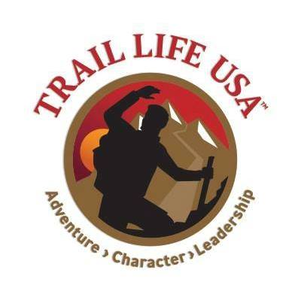

Trailman’s Name: __________________________
Program: [ ] Registered Adult [ ]Mountain Lion Crossover [ ]Navigator [ ]Adventurer

The Summer Adventure participation fee for Sumer Adventure 2021 is $200.00 This fee will be
applied towards travel, activity tickets, food, and other expenses related to the trip and trip preparation. The actual cost of the trip is estimated to be $420.00, with the remaining balance to be raised by fund raisers, sales, workdays, and other events.

After receiving this signed letter, the troop, First Officer Council, and Troop Committee will start the process of reservations, ticket purchases, and trip preparations. The funds collected and earned will be spent. THERE WILL BE NO OPTION FOR REFUNDS if you must back out after the commitment is signed.

Every effort will be made to plan and implement an adventure as described, however changes to participation, location opening, pestilence, funding, and other unforeseen problems may necessitate changes to the events planned. If substantial changes are required a meeting of participants will decide how to proceed.

DATE: July 25 – July 31, 2021

(______) Fees, monies raised, and other funds are non-refundable

(______) Participation in fund raising, workdays, and other events is necessary

(______) Current Trail Life USA membership at the time of the trip is required

(______) Current Trail Life High Adventure medical form will be required

We are excited to plan and implement an adventure to the Ark Encounter for Summer Adventure 2021! By signing below, you are giving your word that you plan to attend and will meet the necessary requirements to participate.

Trailman __________________________________________________ Date _____________________

